**ASSIGNMENT 1**

HTML form

|  |  |
| --- | --- |
| Assignment Date | 19 September 2022 |
| Student Name | A.ABITHARANI |
| Student Roll Number | 820419104002 |
| Maximum Marks | 2Marks |

Question-1:

Create a user registration page form with following fields

Name :

Email:

Name:

City:

State:

Country:

**PROGRAM**

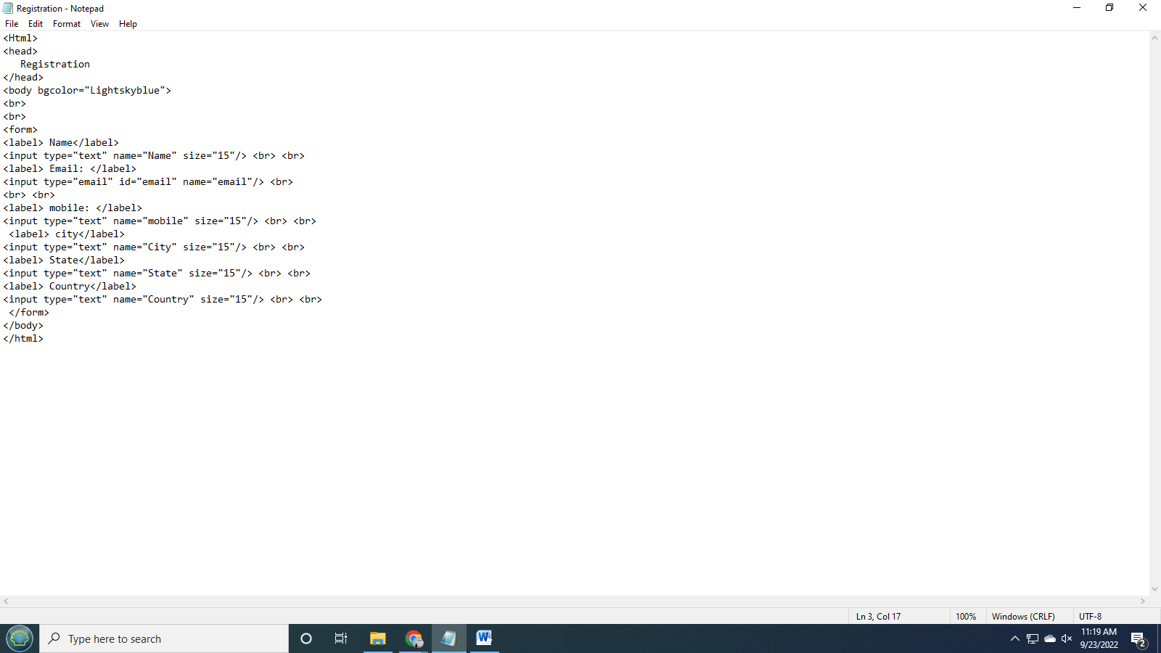

**OUTPUT**

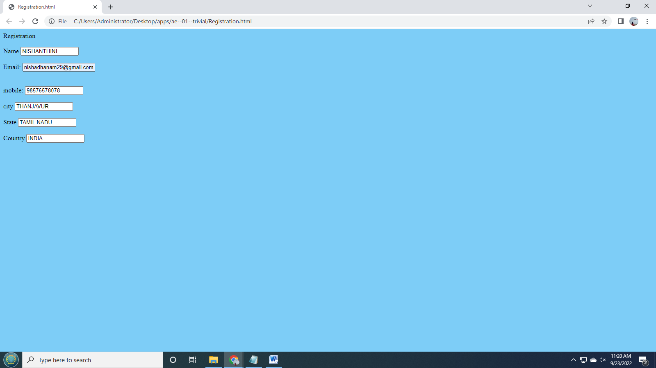

**2. Find out all other html input types :**

<input type="color">

<input type="date">

<input type="file">

<input type="hidden">

<input type="image">

<input type="month">

<input type="number">

<input type="radio">

<input type="reset">

<input type="search">

<input type="time">

<input type="url">

<input type="week">

**3.HTML formatting elements**

**PROGRAM**

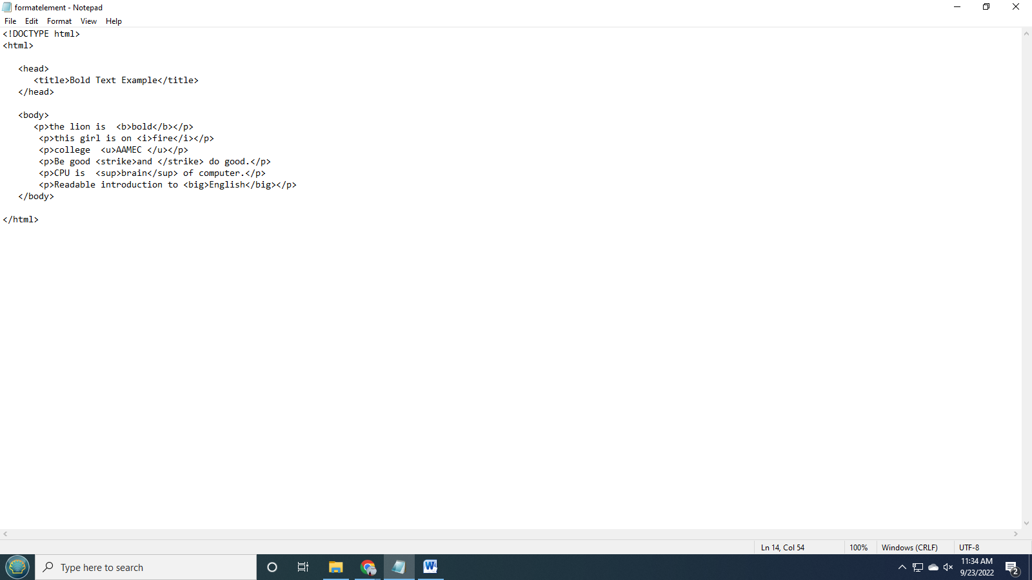

OUTPUT

